SJD Module

Outline Plan

Matthew Farley

90045985

9 October 2013

Contents

User Interface Design 2

Local database selection window 2

Networked database selection Window 2

Server Window 2

Main Window 3

Class Diagram: DB Package 4

Class Diagram: GUI Package 5

Class Diagram: Server Package 6

# User Interface Design

## Local database selection window

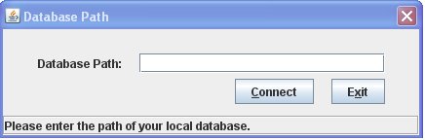

## Networked database selection Window

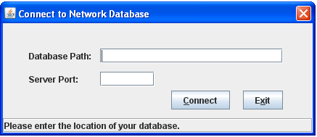

## Server Window

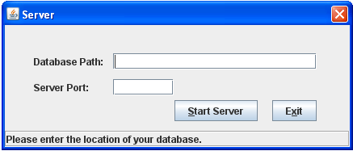

## Main Window

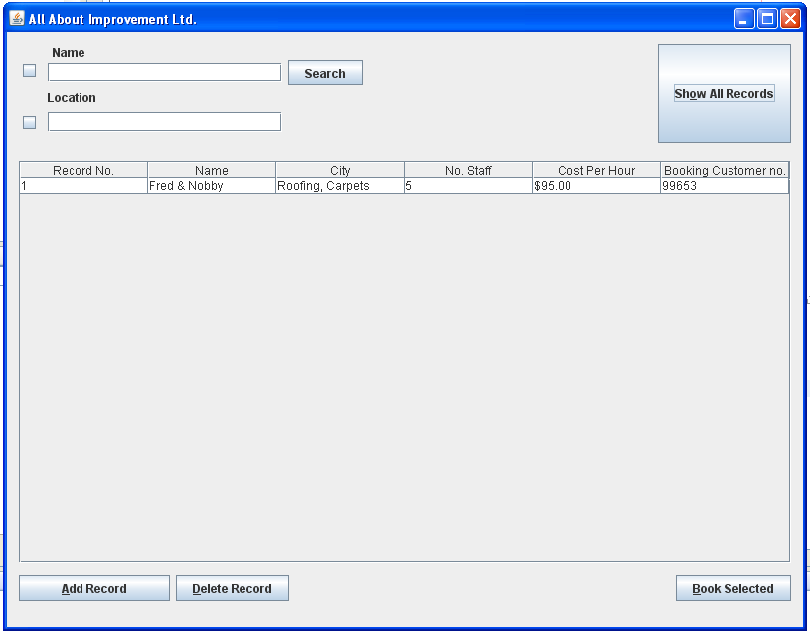

# Class Diagram: DB Package

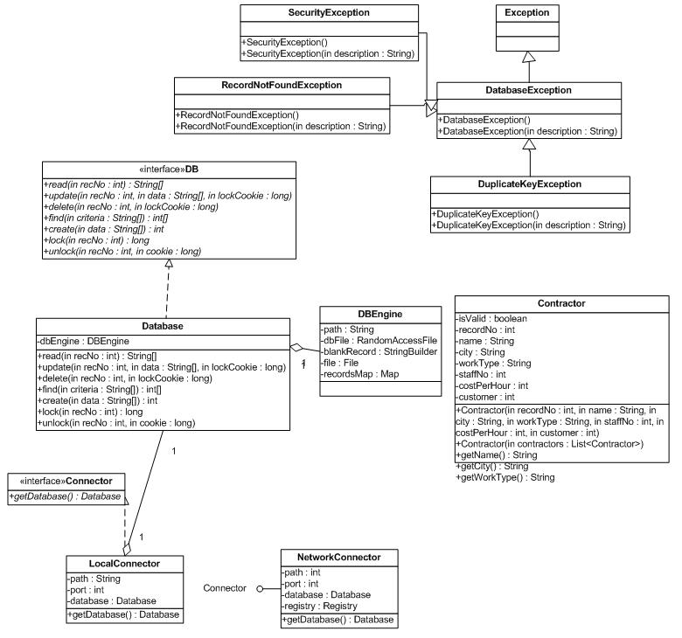

# Class Diagram: GUI Package

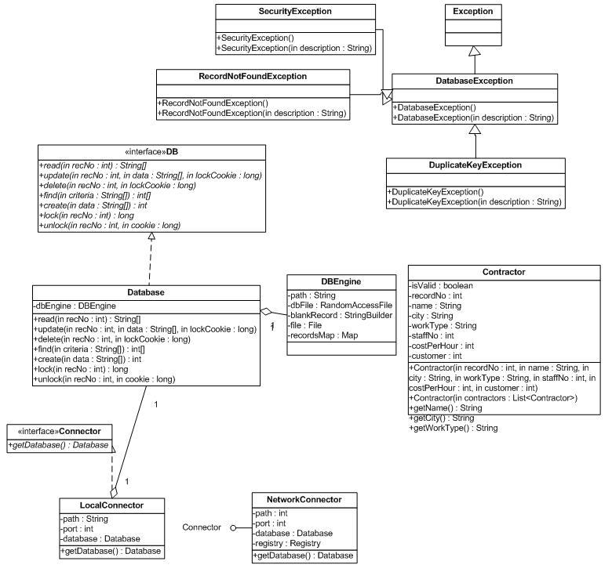

# Class Diagram: Server Package

